Test Case: tc001_SPX_Dev5_Consulta_Administracion_Accesos
Step 1 - Enter username and password and click to button Enter : Credentials Entered
Image file-name: QC_Testing-tc001_SPX_Dev5_Consulta_Administracion_Accesos-dic. 26 2025, 03 28 41 p. m.

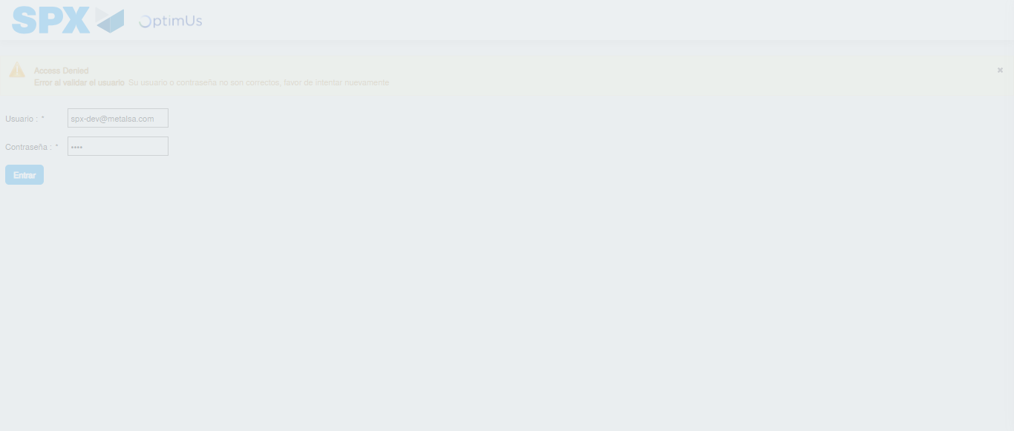Image file-name: QC_Testing-tc001_SPX_Dev5_Consulta_Administracion_Accesos-dic. 26 2025, 03 28 42 p. m.

Step 2 - Select to UEN and Access to Administraci�n de Accesos: UEN Correctly selected and Correct access
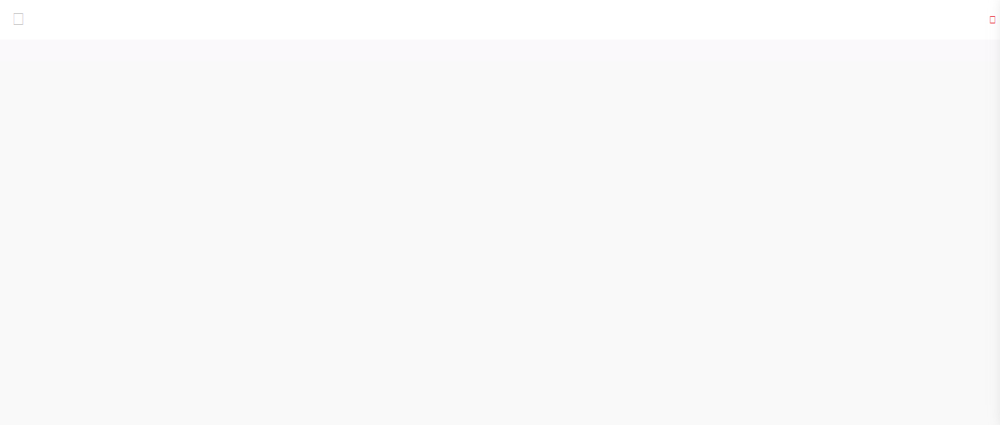Image file-name: QC_Testing-tc001_SPX_Dev5_Consulta_Administracion_Accesos-dic. 26 2025, 03 28 53 p. m.

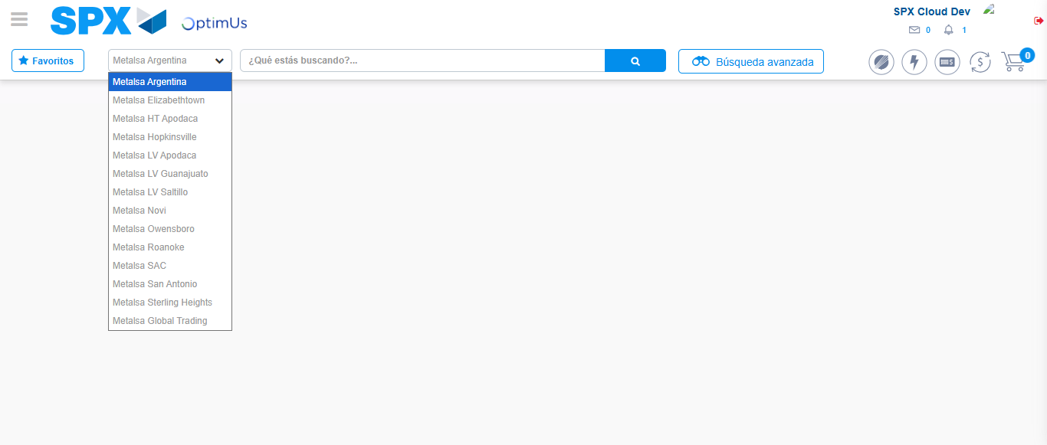Image file-name: QC_Testing-tc001_SPX_Dev5_Consulta_Administracion_Accesos-dic. 26 2025, 03 28 55 p. m.

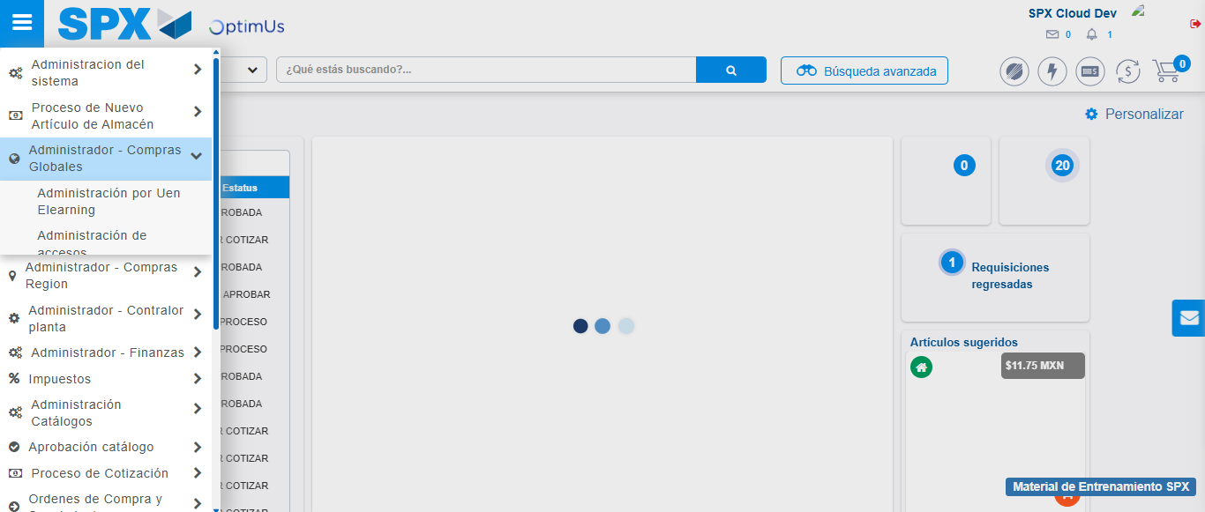Image file-name: QC_Testing-tc001_SPX_Dev5_Consulta_Administracion_Accesos-dic. 26 2025, 03 28 56 p. m.

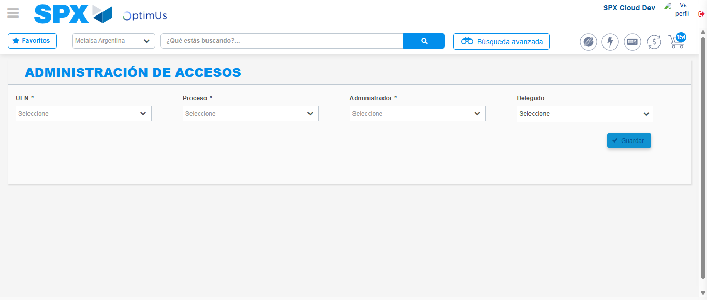Image file-name: QC_Testing-tc001_SPX_Dev5_Consulta_Administracion_Accesos-dic. 26 2025, 03 29 04 p. m.

Step 3 - Review information on Aprobaci�n Catalogos: Correct Data
Image file-name: QC_Testing-tc001_SPX_Dev5_Consulta_Administracion_Accesos-dic. 26 2025, 03 29 04 p. m.

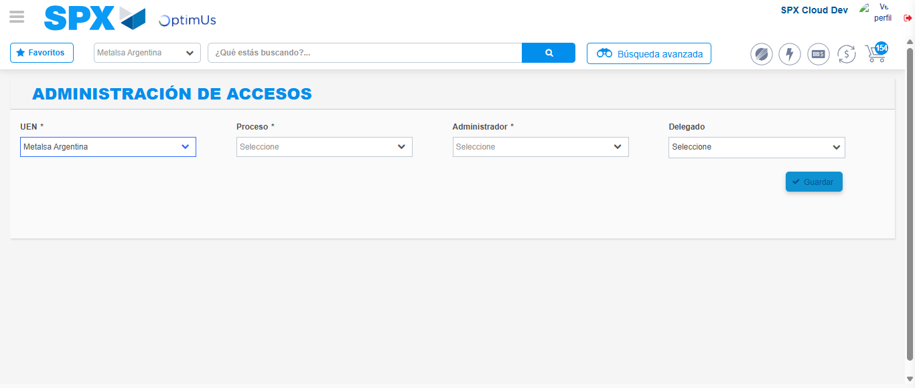Image file-name: QC_Testing-tc001_SPX_Dev5_Consulta_Administracion_Accesos-dic. 26 2025, 03 29 05 p. m.

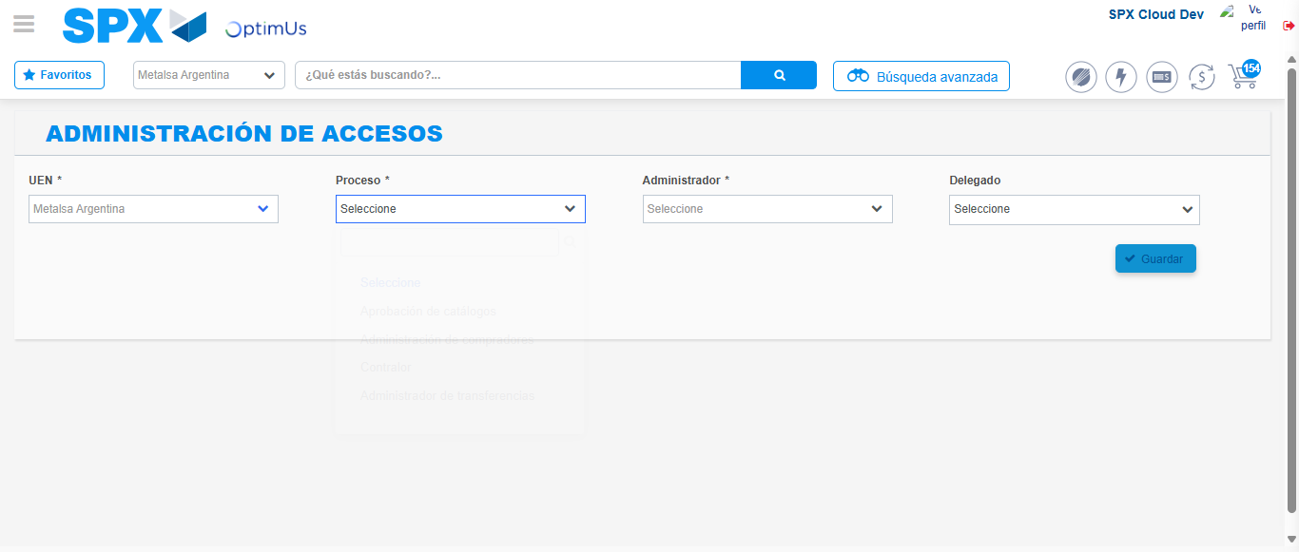Image file-name: QC_Testing-tc001_SPX_Dev5_Consulta_Administracion_Accesos-dic. 26 2025, 03 29 08 p. m.

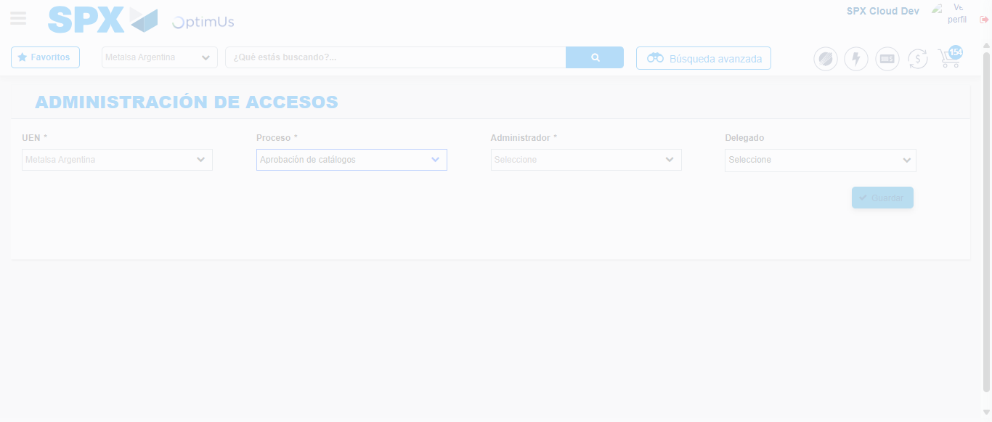Image file-name: QC_Testing-tc001_SPX_Dev5_Consulta_Administracion_Accesos-dic. 26 2025, 03 29 09 p. m.

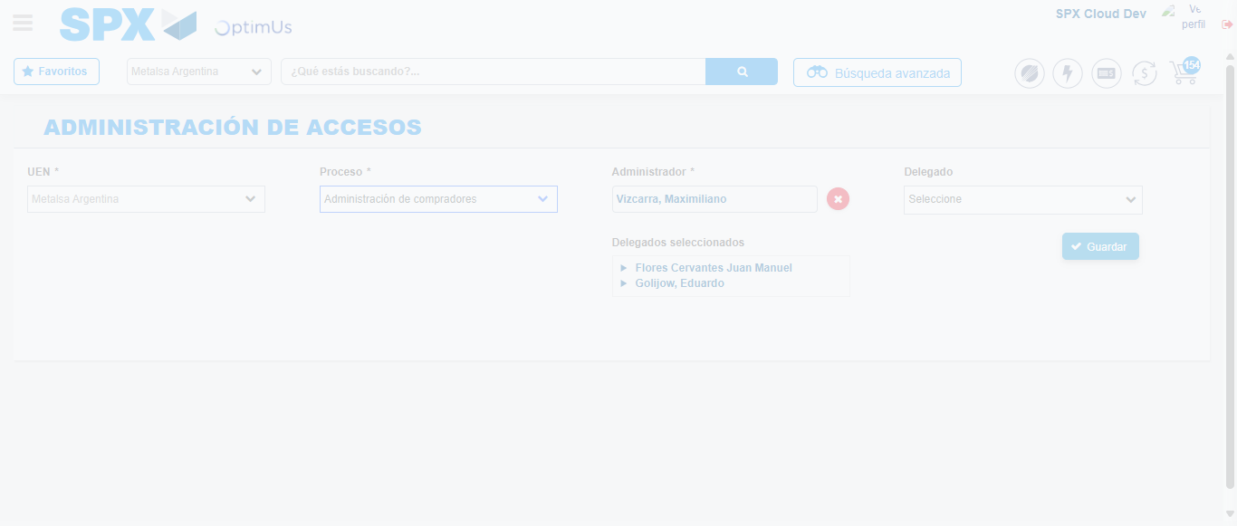Image file-name: QC_Testing-tc001_SPX_Dev5_Consulta_Administracion_Accesos-dic. 26 2025, 03 29 12 p. m.

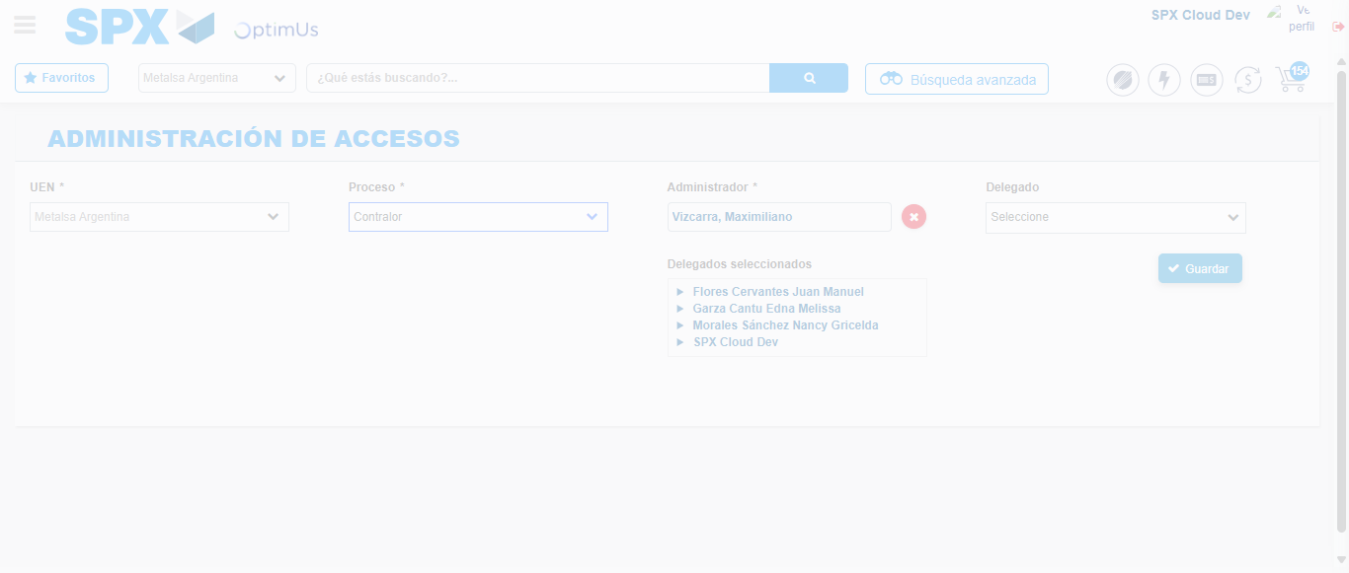Image file-name: QC_Testing-tc001_SPX_Dev5_Consulta_Administracion_Accesos-dic. 26 2025, 03 29 16 p. m.

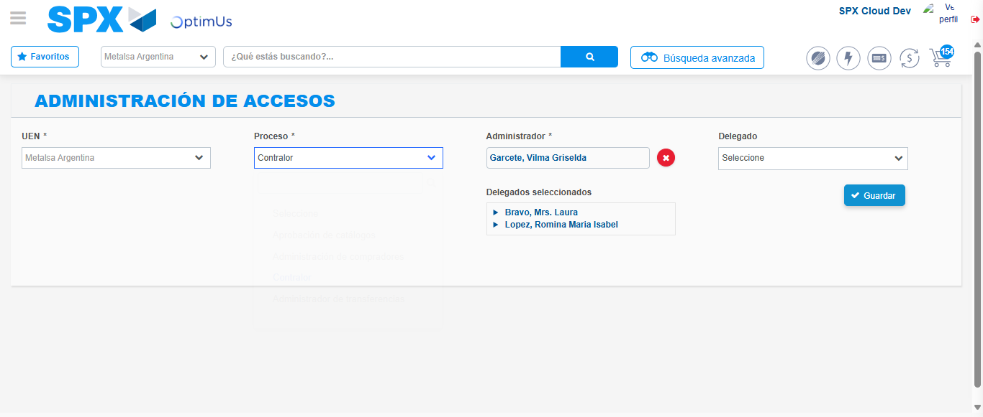Image file-name: QC_Testing-tc001_SPX_Dev5_Consulta_Administracion_Accesos-dic. 26 2025, 03 29 19 p. m.

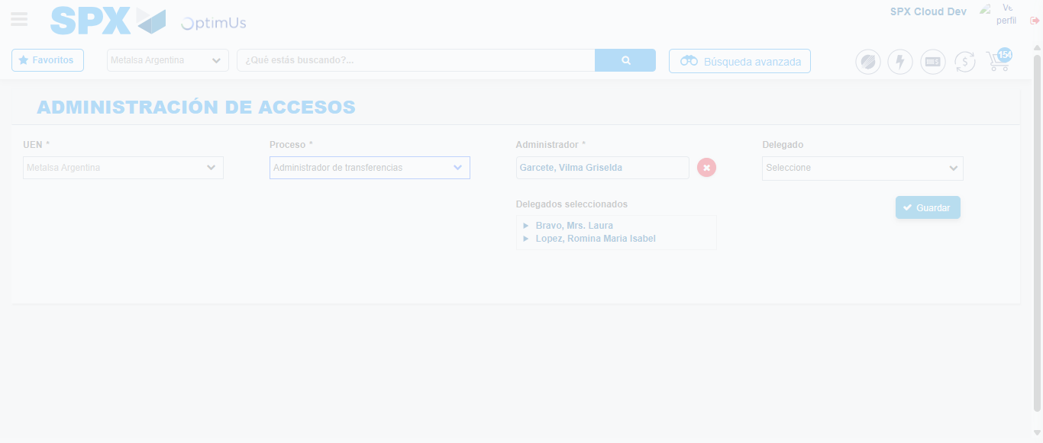Image file-name: QC_Testing-tc001_SPX_Dev5_Consulta_Administracion_Accesos-dic. 26 2025, 03 29 20 p. m.

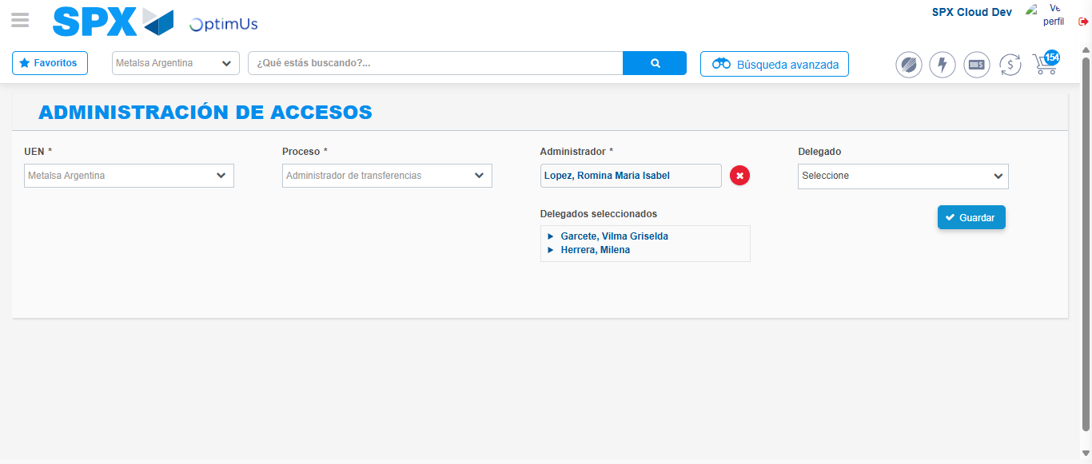Image file-name: QC_Testing-tc001_SPX_Dev5_Consulta_Administracion_Accesos-dic. 26 2025, 03 29 23 p. m.

